Arunai Engineering College 5104

**Project Title:To Supply Leftover Food To Poor**

**Email**:jayakodisenthamilsss@gmail.com

**Name: THENMATHI S**

# Team members: Madhumitha S , Saranya V , Poongodi P

**1. Project Overview**

This project, titled "To Supply Leftover Food To Poor” is designed

The goal of this project is to reduce food waste by redistributing leftover food from restaurants, households, and events to impoverished individuals and communities. By redirecting surplus food to the poor, the initiative will help alleviate hunger, reduce food waste, and raise awareness about food insecurity in society. project aims to bridge this gap by collecting excess food from businesses, events, and households, and redistributing it to people in need. The project seeks to create a sustainable model of food distribution that alleviates hunger, reduces waste, and fosters community solidarity.

## 2. Objective

# Business Goals

# Reduce Food Waste:

Redirect surplus food from restaurants, events, households, and stores prevent it from being wasted.

Partner with local food suppliers and businesses to collect and redistribute food that would otherwise be discarded.

# Alleviate Hunger and Food Insecurity:

Provide nutritious meals to low-income families, homeless individuals, and vulnerable populations who lack access to sufficient food.

Ensure that people in food deserts or underserved areas receive regular access to quality meals.

## Raise Awareness About Food Waste:

Educate the public on the environmental and social impacts of food waste.

Encourage individuals, businesses, and organizations to adopt sustainable practices and support initiatives that reduce waste and promote food redistribution.

# Ensure Safe and Hygienic Food Handling:

Establish protocols for food collection, storage, and transportation that adhere to food safety regulations to ensure the food is safe to consume.

Set up proper training programs for volunteers and staff on handling, packing, and delivering food safely.

# Increase Access to Nutritious Meals:

Focus on distributing balanced, healthy meals that meet the nutritional need of recipients, particularly for children, elderly, and vulnerable groups.

## Specific Outcomes:

* 1. Admission Application Management: Implement an online admission form l Enable automated email notifications and generate reports to track application metrics, acceptance rates, and enrollment trends.

* 1. Approval Process: Establish a Salesforce-based approval process for consulting requests with automatic email alerts for approved or rejected statuses, ensuring timely communication.
  2. Consulting Services Management: Facilitate consulting requests with automated notifications to consultants and enable appointment scheduling and tracking within Salesforce, including real-time status updates (scheduled, completed, canceled).
  3. Immigration Case Management: Implement a case submission form, integrate document management, and track case status to manage immigration inquiries efficiently, enhancing service accuracy and response time.

1. **Salesforce Key Features and Concepts Utilized**
   * **Objects and Data Modeling**:

Custom objects for Admissions, Consulting Requests, and Immigration Cases were created to store and organize essential student and application data.

* + **Process Builder and Automation**:

Automated workflows were developed to streamline admission notifications, consulting request approvals, and immigration case updates, reducing manual work and improving response times.

* + **Approval Processes**:

Approval workflows were implemented for consulting requests, allowing students to receive automated status updates and staff to manage approvals directly in Salesforce.

* + **Email Alerts and Notifications**:

Automated email notifications were set up for key actions, including application submission confirmation, consulting request updates, and immigration case notifications, ensuring timely communication with students and staff.

* **Reports and Dashboards**:

Custom reports and dashboards were created to provide admissions staff with insights into application metrics, consulting trends, and immigration case statuses, supporting data-driven decision-making.

* + **Appointment Scheduling**:

Built-in scheduling within Salesforce allowed consultants to manage consulting appointments with students, tracking dates, times, and appointment purposes.

* + **Case Management for Immigration**:

Salesforce’s case management features enabled efficient tracking and updating of immigration case statuses, along with integrated document management and collaboration tools for case processing.

1. **Detailed Steps to Solution Design**

1. **Create Objects from Spreadsheet**

**Create Venue object**

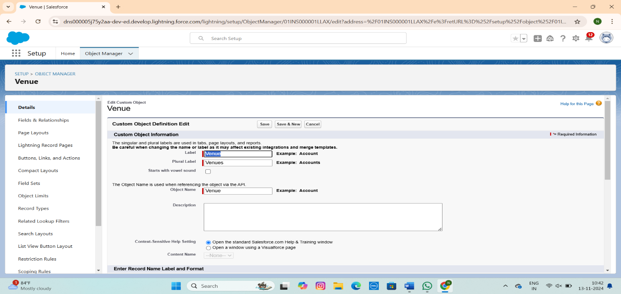

## Create Drop-off Point Object

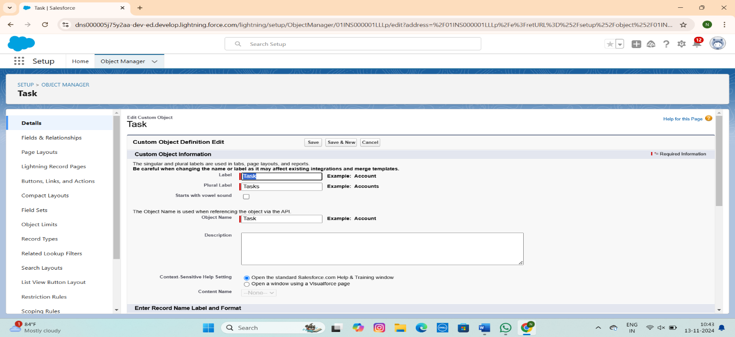

* Create Task Object

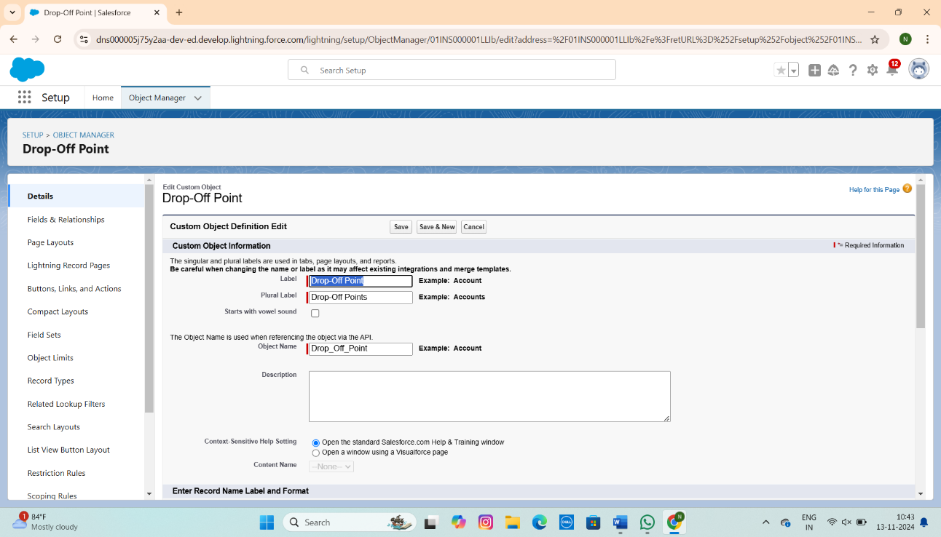

* **Create Execution Details Object**

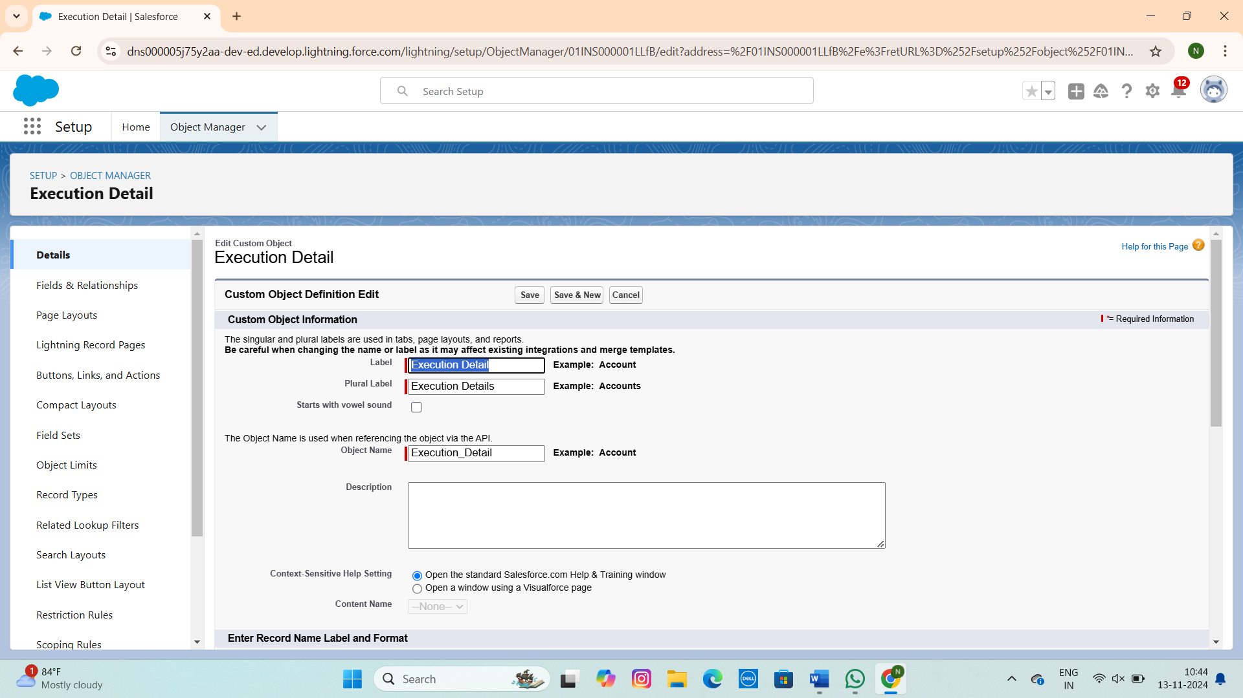

**Create a Lightning App**

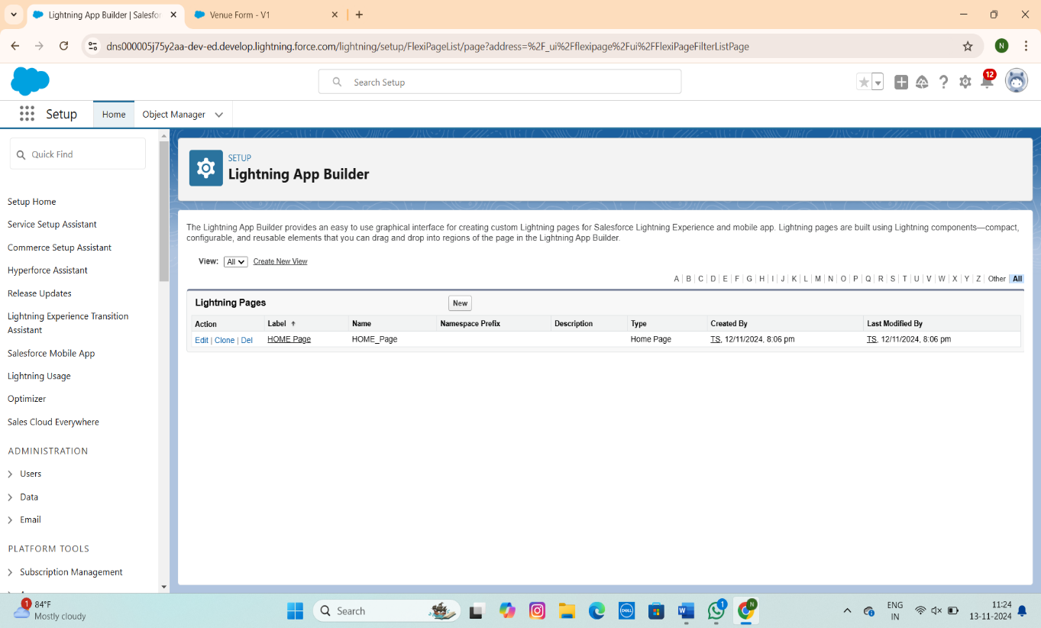

**Create a ScreenFlow**

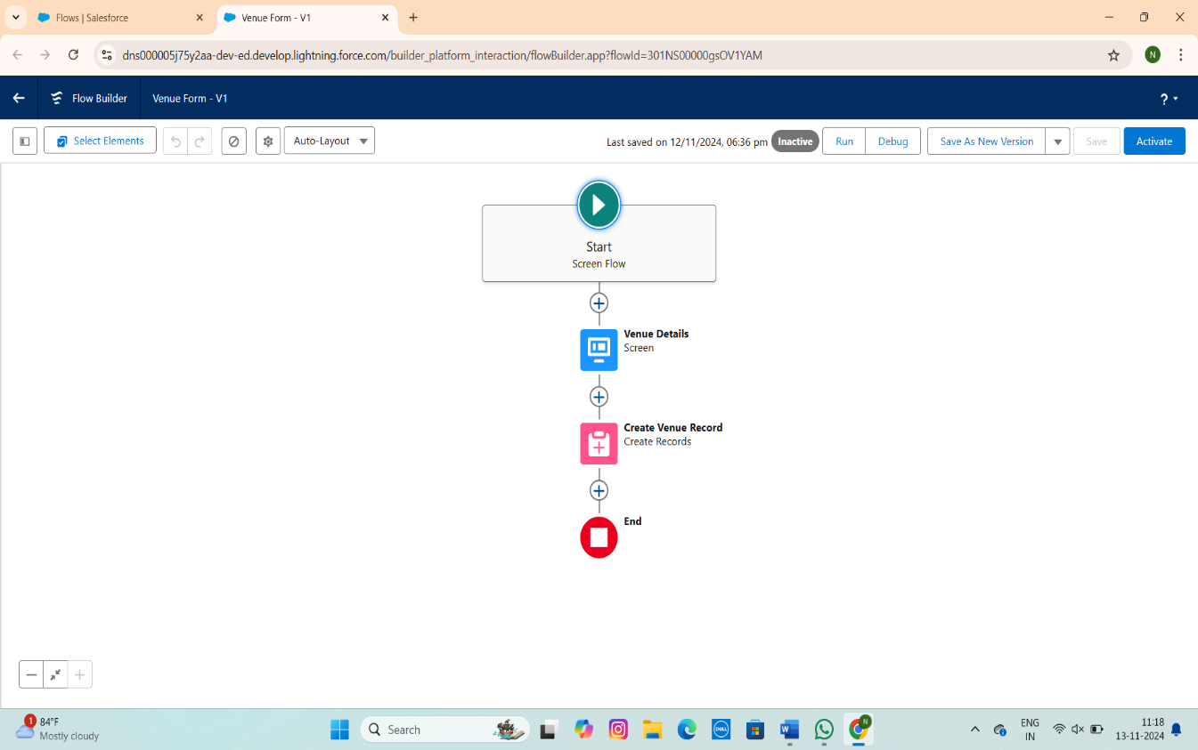

**Create a Report**

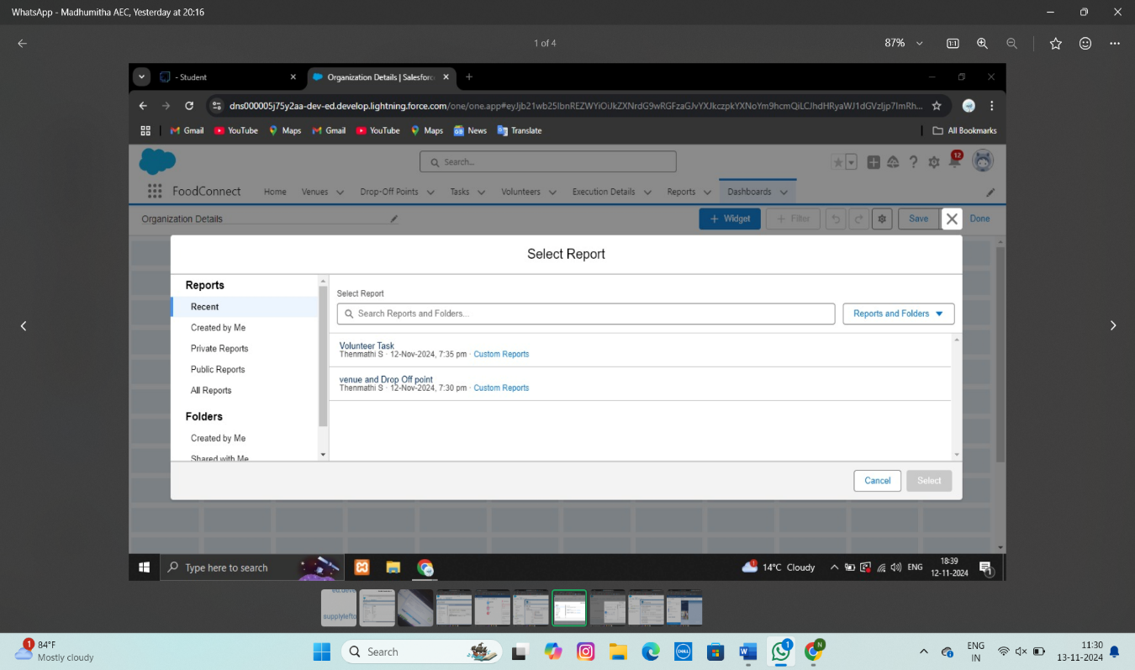

## Create Users

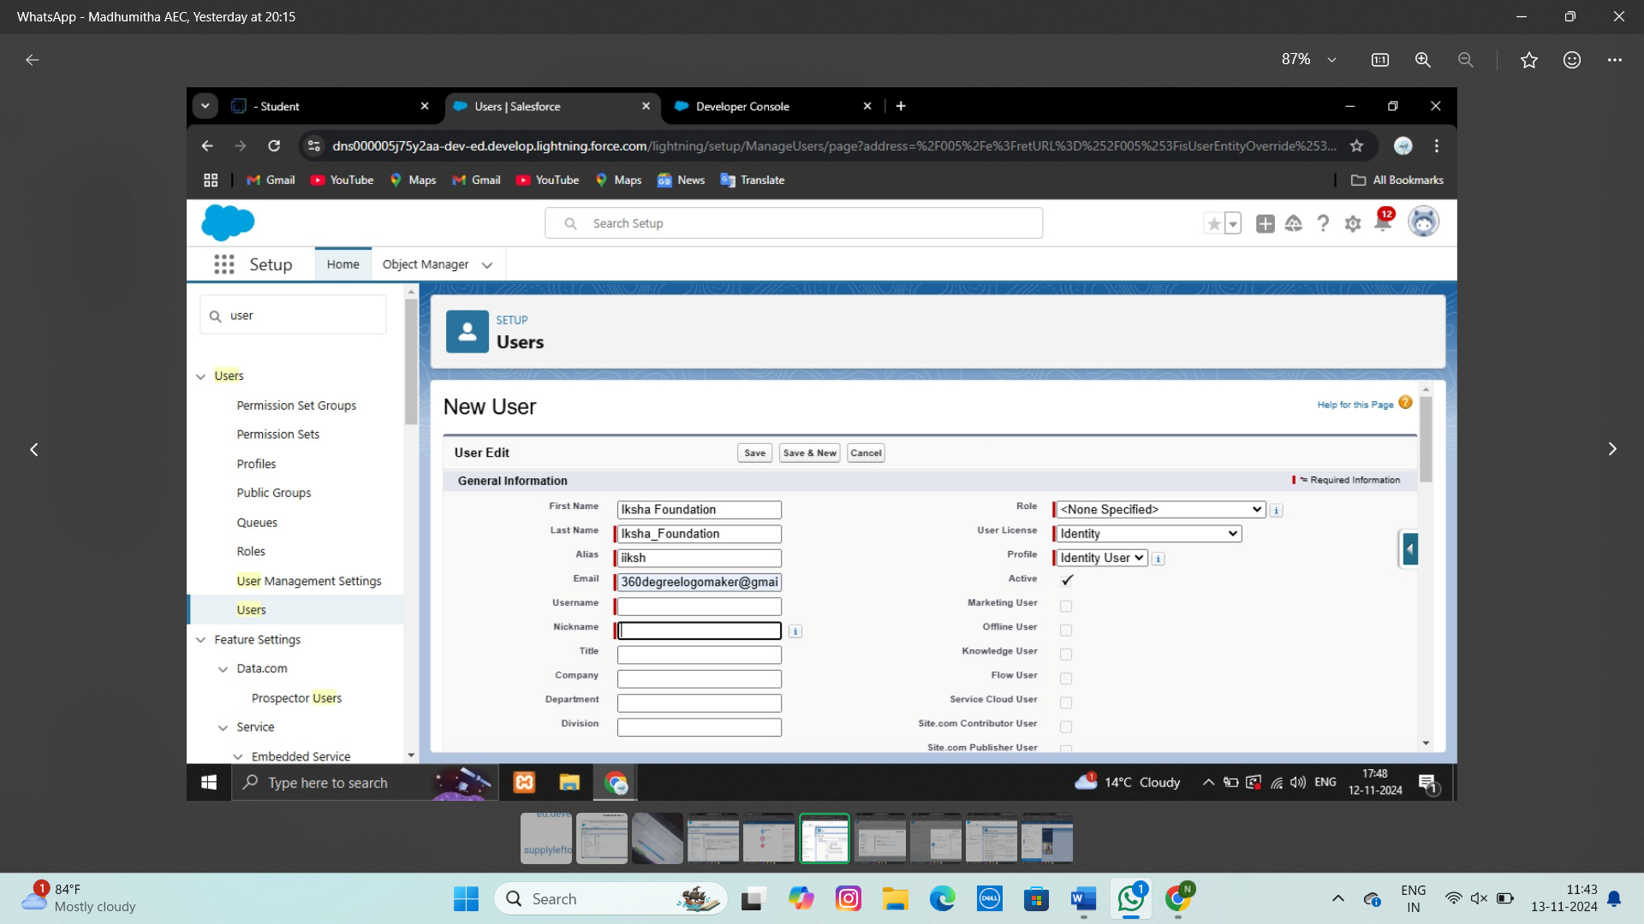

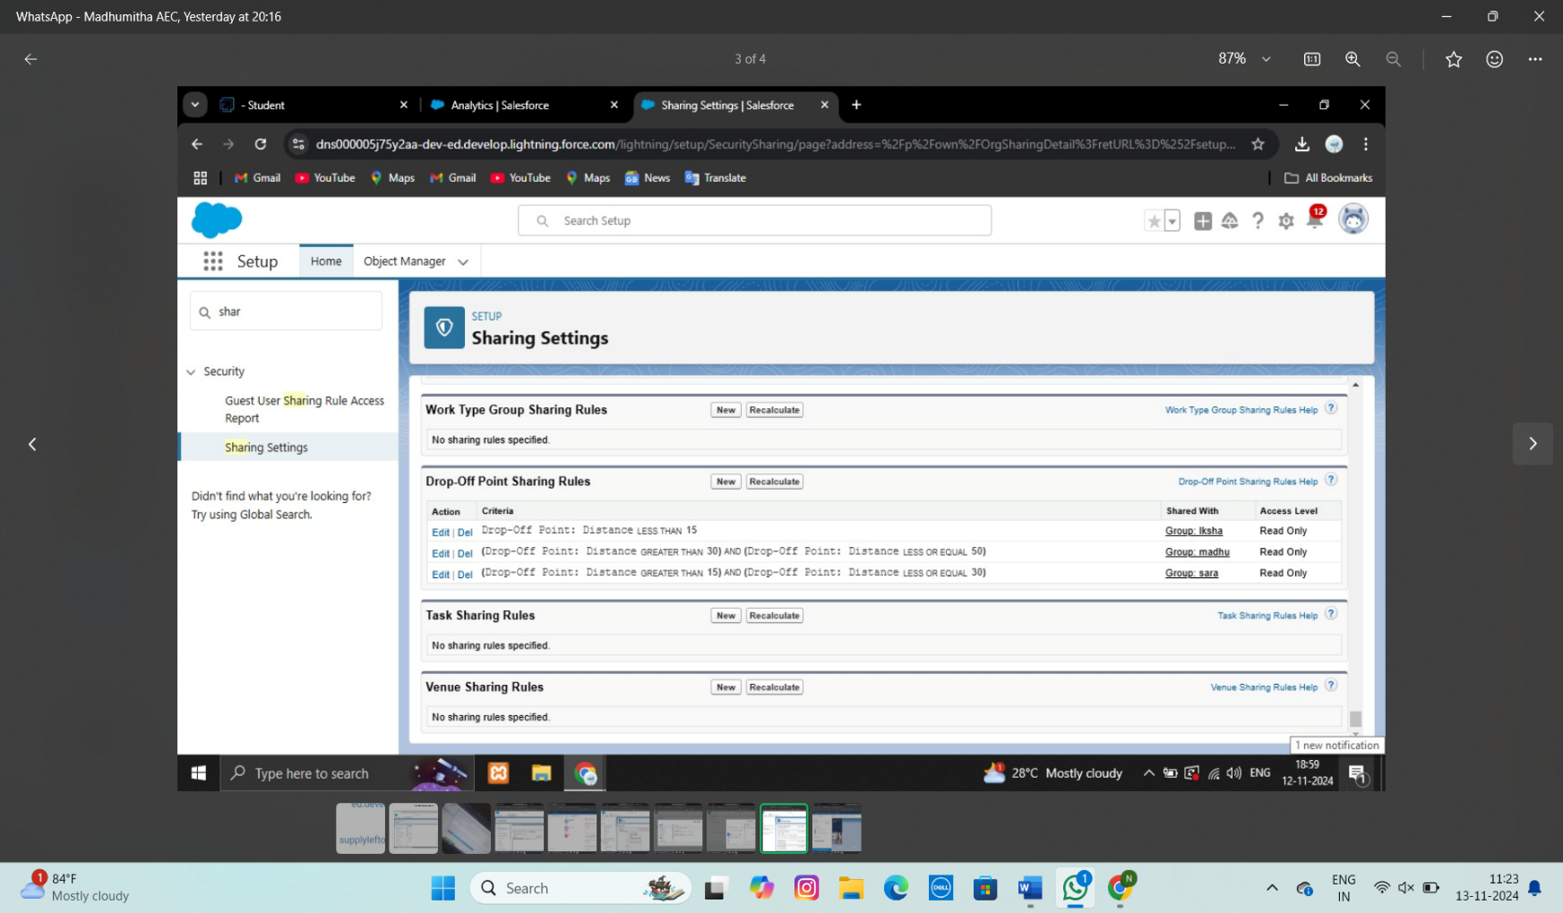

## 

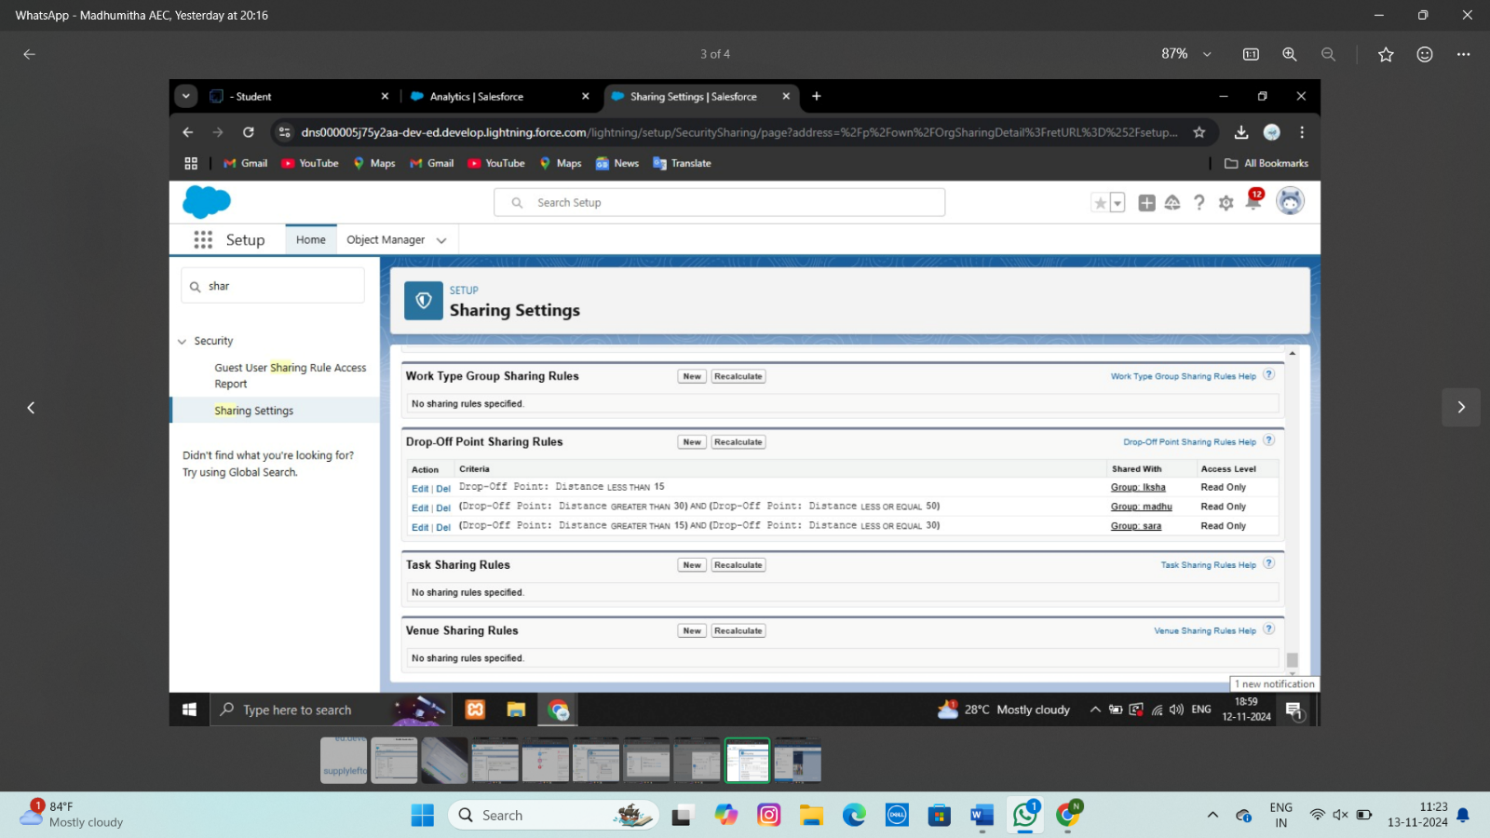

**Create a lightning app page**

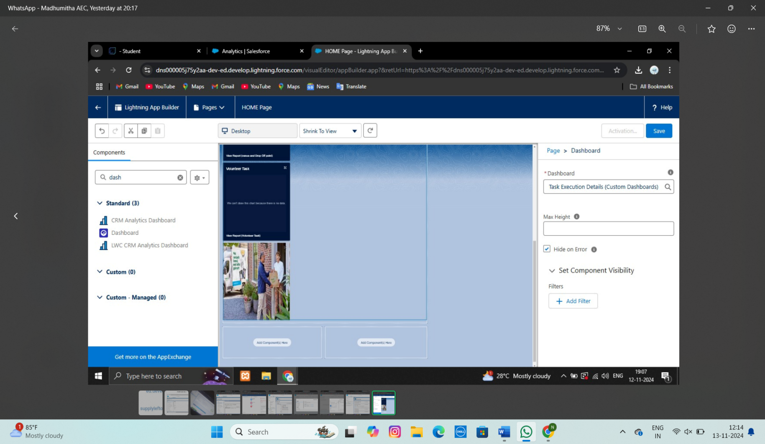

**Testing and Validation**

# Pilot Program:

* Start small in a specific area (e.g., neighborhood or community) to evaluate the logistics, food safety, and response from both donors and recipients.
* Collect feedback from all stakeholders (food donors, volunteers, and recipients) to identify gaps or challenges.

# Logistical Testing:

* Evaluate the transportation, storage, and handling processes to ensure food stays safe and uncontaminated.
* Test distribution systems (e.g., door-to-door, central collection points)

Validated that users could navigate seamlessly across tabs for Appointment, Courses, Consulting Requests, and Immigration Cases without performance issues.

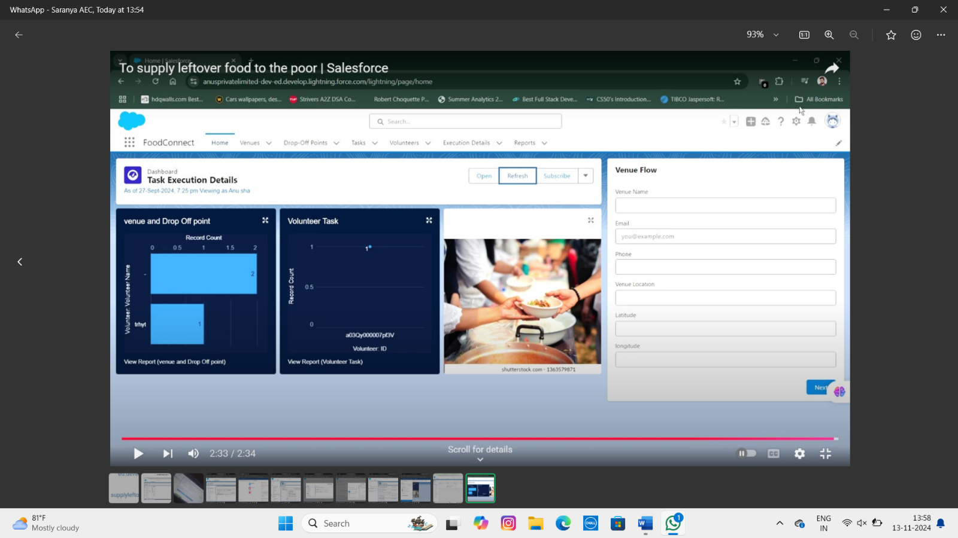

1. **Key Scenarios Addressed by Salesforce in the Implementation Project**

In a Salesforce implementation project aimed at supplying leftover food to the poor, several key scenarios are typically addressed to ensure smooth operations and impactful service delivery. These are include:

# Food Donation Management:

* The system tracks donated food items, including details like food type, quantity, expiration date, and donor information. Salesforce can automate reminders to ensure food is distributed before expiration.

# Donor and Recipient Management:

* Salesforce allows for the creation and management of profiles for both food donors (e.g., restaurants, supermarkets, individuals) and recipients (e.g., shelters, community kitchens). This ensures that donors and recipients are properly matched and can be easily contacted.

# Inventory Tracking and Distribution:

* The system can monitor inventory levels of donated food and generate real-time updates on food availability. This helps ensure that the available food is distributed efficiently to recipients in need.

# Volunteer Coordination:

* Salesforce can facilitate the management of volunteers involved in collecting, packaging, and distributing food. Scheduling, tracking volunteer hours, and assigning tasks can all be automated within the system.

Food Safety: Ensure food handling, storage, and delivery meet health standards (e.g., temperature control, proper packaging).

* Quality Assurance: Ensure that the food being distributed is still consumable and not expired or spoiled.
* Community Impact: Measure how effectively the project is reaching its target population (e.g., number of people served, quantity of food distributed).
* Feedback Loop: Develop mechanisms for recipients and donors to provide feedback (e.g., surveys or interviews).
* Sustainability: Assess whether the program can continue long-term without running into financial or logistical bottlenecks.

**Impact Tracking and Reporting: Salesforce allows the tracking of metrics related to the project’s impact, such as the number of people served, the quantity of food distributed, and the environmental or community benefits. Customizable reports can show trends and outcomes for stakeholders and funding agencies.**

**Regulatory Compliance and Food Safety: Salesforce can be configured to ensure that all food donations meet safety regulations, tracking expiration dates, food types, and hygiene standards to ensure safe distribution.**

**Donor Engagement and Recognition: The platform can automate thank-you emails, certificates, or recognition for donors, helping maintain strong relationships and encouraging future donations.**

**Providing for the Underserved:**

* Leftover food can help meet the nutritional needs of individuals and families who are food-insecure or living in poverty. This can significantly improve their access to quality meals, especially in urban areas where food scarcity can be an issue.

**Ensuring Nutritional Balance:**

* Donating surplus food ensures that those in need receive balanced meals, often including fresh fruits, vegetables, and other nutritious options that may otherwise be inaccessible to them.

**Reducing Operational Costs:**

* Nonprofits and community organizations that provide meals to the poor can save money by receiving leftover food from restaurants, supermarkets, or individuals, reducing their food purchasing costs.

**7. Conclusion**

**Summary of Achievements:**

The "Supplying Leftover Food to the Poor" project represents a significant opportunity to tackle two urgent societal issues: food insecurity and food waste. By collecting and redistributing excess food that would otherwise go to waste, this initiative has the potential to provide immediate relief to those facing hunger while simultaneously promoting sustainable practices in food consumption. The project not only helps reduce the environmental impact associated with food waste but also improves the quality of life for vulnerable communities by ensuring they have access to nutritious meals.

Moreover, the project can foster a sense of social responsibility and community solidarity. It encourages local businesses, restaurants, and individuals to be more mindful of their food consumption patterns and to take proactive steps in contributing to the welfare of others. By leveraging a network of volunteers and partners, this initiative can create a collaborative ecosystem where excess food is efficiently redistributed to those in need.

In conclusion, the "Supplying Leftover Food to the Poor" project is a practical and impactful way to address hunger and food waste, with the potential for both immediate and long-term positive outcomes. With careful planning, collaboration, and community engagement, this project could make a meaningful contribution to alleviating food insecurity and promoting a more sustainable and equitable food system.